|  |
| --- |
| **10.014: Computational Thinking for Design 1D Project**  **Stock Trading Game**  **Description and Documentation**  **Group 1D F09-E** |
| **Marcus Chao 1005905**  **Lee Chun Wai 1006004**  **Liew Min Hui 1006166**  **Lucas Yap 1006356**  **Anirudh Bharadwaj 1006285** |

## Description

**Scenario.** This game is aimed at teenagers. With many young adults being increasingly interested in investing and stocks, they will be interested in learning how the stock market works. This game will introduce the basics of how stocks work and to show how current events affect stock prices. Teenagers are often using their laptops to learn using online resources and to play games. Thus, it will be engaging to learn about stocks through a game on their laptops.

**Description of the game.** This is a single-player game. Users are given a starting capital of $1000 and go through a series of 5 rounds. Users are presented a news article at each of the 5 rounds and are given the option to buy or sell 4 different stocks (limited by existing capital). At the end of the game, users will be able to see if they have managed to increase, maintain or decrease their starting capital. From this, users will be able to learn about the effects of different events on different stocks.

Documentation

**Structure.** The game is structured as follows:

1. **Importing tkinter.** As the game uses a GUI, tkinter is imported. ttk is also imported from tkinter to allow for the use of tkinter themed widgets
2. **Reading files.** The game uses text from a text file, news.txt. This text file is open and read, and text inside the file is converted into a list using the .split() method. The text file splits the news for the different turns of the game with a “+” sign.
3. **Defining Variables.** A few global variables are used throughout the game which will be covered later in the documentation
4. **Fixing a data list.** The ‘data’ variable is a list of lists. Each list represents the data required to be updated each turn. The nested lists are structed as follows:
   1. Index 0: News for the turn
   2. Index 1: Price of stock 1
   3. Index 2: Price of stock 2
   4. Index 3: Price of stock 3
   5. Index 4: Price of stock 4
5. **Defining functions.** A few functions are used throughout the game which will be covered later in the documentation
6. **Creating an instance of a tkinter window.** “root=Tk()”
7. **Creating frames, labels, and buttons.** Frames, labels, and buttons are all widgets within tkinter which make up the GUI.
8. **Placing the widgets in a grid.** Given the demands of the GUI, the .grid() method must be used on each widget for them to be placed in an organised manner within the displayed window.
9. **Configuring the columns and rows to scale.** The columns and rows within the window must be able to scale with the window when it is resized. A for loop is used within this segment to loop through all of the rows and columns and configure them to scale using the .columnconfigure() and .rowconfigure() methods.

**Variables.**

1. capital:

This is an integer which represents how much money the user has at the current moment

1. stk1,stk2,stk3,stk4:

These are dictionaries which represent each stock. They each contain 3 key-value pairs corresponding to the stock’s name, the quantity of the stock which the user owns, and the price of the stock

1. error_msg:

This is a string which is initially empty. In the event that the user tries to take an invalid action, this string is updated and displayed accordingly.

1. storycounter:

this is an integer which is initially set to -1. This value is incremented each time the user presses the “next turn” button and is used as a pointer to go through the data list mentioned earlier.

**Functions.**

1. buy(stk,stkq) function:

The buy function takes the stock and the stock quantity labels as input parameters. If the user has less capital than the price of the stock, then the global error_msg variable is changed accordingly and the error label is updated. If the user has sufficient capital, the quantity of the stock increases by 1 and the global variable capital is reduced by the price of the stock. The stock quantity and capital labels are updated and the error label is cleared.

1. sell(stk,stkq) function:

The sell function takes the stock and the stock quantity labels as input parameters. If the user does not have any of the specified stock (i.e. its quantity is 0), then the global error_msg variable is changed accordingly and the error label is updated. If the user owns the stock, the quantity of the stock is reduced by 1 and the global variable capital is increased by the price of the stock. The stock quantity and capital labels are updated and the error label is cleared.

1. next_turn function:

The next_turn function takes no input parameters. However, it uses the global storycounter variable to determine what set of stock prices and news should be shown. It then increments the storycounter by 1. Once the storycounter reaches 4, it updates the text displayed on the button from “next turn” to “end game”. Once the storycounter reaches 5, it clears the frame and displays some text to indicate to the user that they have finished the game.

1. check_capital function:

The check_capital function takes no input parameters. It checks the global capital variable and returns a message depending on how much capital is left at the end of the game. This message lets the user know how they have performed. This function is used within the next_turn function.

1. clearFrame function:

The clearFrame function uses a for loop to clear the widgets within a frame. This function is used within the next_turn function.

**Required Files.** The game requires both the stock_game.py and news.txt files within the same file directory to be run. As mentioned earlier, the game reads from the text file ‘news.txt’. This text file contains the news to be displayed separated by “+” to allow for the text to be split into a list containing each turn’s text.

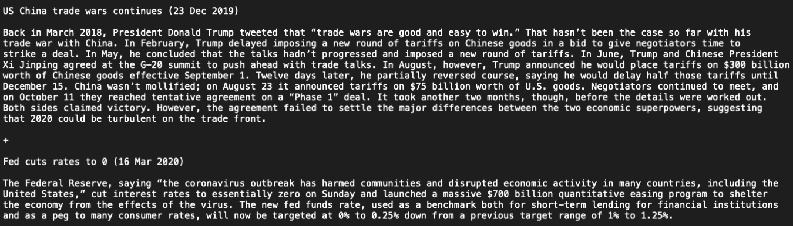

Figure 1: An example of some of the news in the news.txt file